



CARE Group

Supervisor | Sir Asif Ahmed Khan
Batch | PR2-202301C1+01C
Group | A
Serial No. | Enrollment Number | Student’s Name
1 | Student1445260 | Zain Ahmed Khan
2 | Student1448923 | Ibrahim Khurram
3 | Student1451678 | Uroosa Ali
4 | Student1448324 | Taseen Bin Azhar

Table of content

- Table of Contents.……………………………….…….……………...02
- Certificate of Completion……….………………………….….……....03
- Acknowledgement………………………………………….……...….04
- Problem Statement….………………………………...……....…..…..05
- Functional Specifications……………………………………...…….…05
- Hardware and Software Requirement…………..……….…….….……..06
- Project Synopsis…………..…………………………..…….….……..07
- Website Features …………..…………………………..…….…..…...07
- Database Design………….....……………………….......…….…..….08
- User Guide………….....……………………....………….….…..…..09-14
- Admin Dashboard………….....……………………....……….…..….15-18
- Doctor Dashboard………….....……………………....……….…..….19-21
- Developer Guide………….....……………………..……….….…..….22-26
- Task Sheet………….....……………………..……………..….…..…27
- Checklist of Validation …………..……………………....…….…..…..28
- Submission Checklist………….....……………………....…….…..…..28
- Flowcharts………….....……………………..…….…..…..…………29-31

Certification of Completion

This is to certify that Zain Ahmed Khan, Ibrahim Khurram, Uroosa Ali, Taseen Azhar have successfully completed their ACCP Prime 2.0
Semester II E-Project.

Submitted to: Aptech Computer Education
On
January 7th, 2024

Acknowledgment

First of all we would like to thank Almighty Allah for giving us strength and ability to complete this project.
And then, we would like to express my special thanks of gratitude to our teacher Sir Sir Asif Ahmed Khan who guided us on the project CARE Group, which also helped us in doing a lot of new learning and we came to know about so many new things we are really thankful to him.
We are highly thankful to Sir Asif Ahmed Khan for his guidance and constant supervision as well as for his support in completing the project.
Lastly, we would also like to thank our parents and friends who helped us a lot in finalizing this project within the limited time frame. We also express our sincere gratitude to I-Project team from Aptech Head Office, for their valuable guidance and support for the completion of this project. We earnestly hope that this project will provide all the necessary information required by the user to fulfill his/her inspiration. However, suggestion and Feedbacks for improvements will be thankfully welcomed & acknowledged

Problem Statement

We all need to visit doctors some time or the other. Sometimes it is an emergency situation, whereas most of the other time it is a planned checkup/visit. But in both the cases we have to visit the doctor to take an appointment or wait in long queues.
CARE Group is into medical services for long time and looking at the current medical scene have decided to come up with a WEBSITE, which will host the medical services available in different cities.
Individuals will be able to search for specialist doctors in their surroundings and even book online appointments.
Web site should also record the complete information regarding the Doctors and Patients.

Functional Specifications

Website will host information about common Diseases, Preventions and Cures. It will also display the latest medical news and information on inventions in Medical Science.
The website will have three users/roles:
- Administrator
- Doctor
- Patient

The Administrator should be able to do the following:
- Add Cities to the master database.
- Add Doctors to the Master database.
- Modify Doctor Details.
- Modify Patient Details.
- Delete Cities
- Delete Doctors
- Delete Patients
- Create/Manage Users/Logins
- Manage information/details on the WEBSITE

The Doctor should be able to do the following:
- Login into the system with his USER/PASSWORD
- View his/her profile details
- Add details to his/her profile
- Modify his/her profile
- View Appointments
- Update his availability for DAY/WEEK/MONTH

The Patient should be able to do the following:
- Register/Create Account [USERID should be unique].
- Search Doctor based on location, Specialist
- Book Appointment [Check Availability]

Note: Name, Address, Phone Numbers, Email-ids should be mandatory to be provided.

Hardware/Software Requirements

Hardware
- A minimum computer system that will help you access all the tools in the courses is a Pentium 166 or better
- 128 Megabytes of RAM or better

Operating System
- LINUX / Windows 2000 Server (or higher if possible)

Software
- PHP
- MySQL
- PERL
- Apache

Project Synopsis

"CARE Group introduces an innovative and specialized healthcare management platform designed to enhance patient care and streamline healthcare processes. The platform incorporates a user-friendly Admin Panel, empowering healthcare professionals with a dedicated application for efficient patient management. Upon submitting patient requests, authorized users log in to access a comprehensive interface for patient assessment and care coordination. The system allows healthcare providers to either approve patient care plans for further implementation or reject them based on their evaluation. The administrator is equipped with distinct pages for approved and rejected care plans, offering a transparent and organized view of patient management outcomes. The CARE Group project aims to revolutionize healthcare delivery by optimizing care planning and decision-making processes."

Website Features

"The CARE Group's website offers a robust healthcare management ecosystem, featuring an extensive service catalog that spans patient care plans, medical records, appointment scheduling, and more. The platform facilitates real-time tracking of patient progress and treatment plans, providing users with updates on approvals and adherence to healthcare standards. It includes an intuitive interface for comprehensive patient assessment and care coordination, enhancing communication among healthcare providers, patients, and administrative staff. The system's notification system ensures timely updates on care plan approvals, appointments, and other critical information. By seamlessly integrating various healthcare stages, the CARE Group website prioritizes transparency, collaboration, and quality healthcare delivery.

Database Design

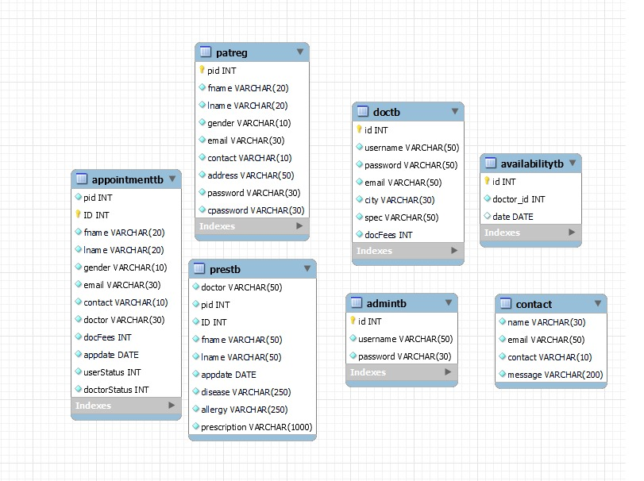

User’s Guide

Home Page:

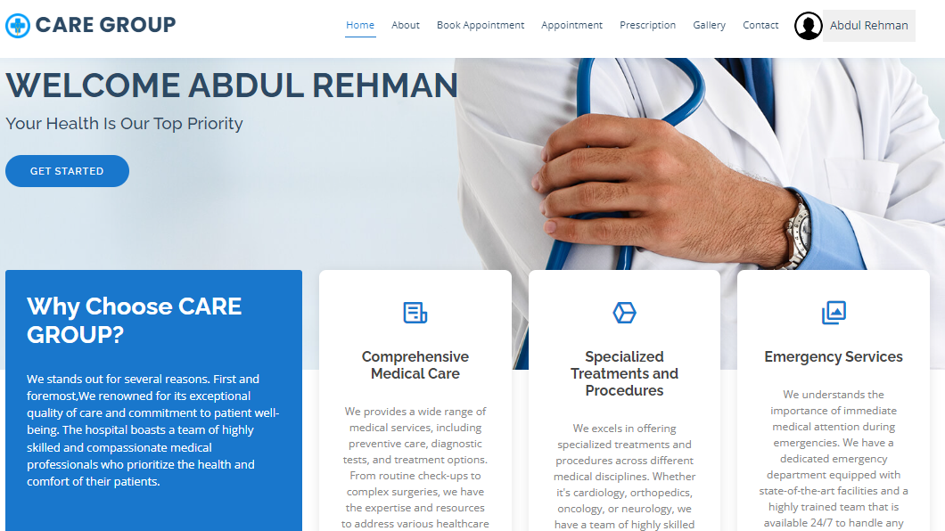

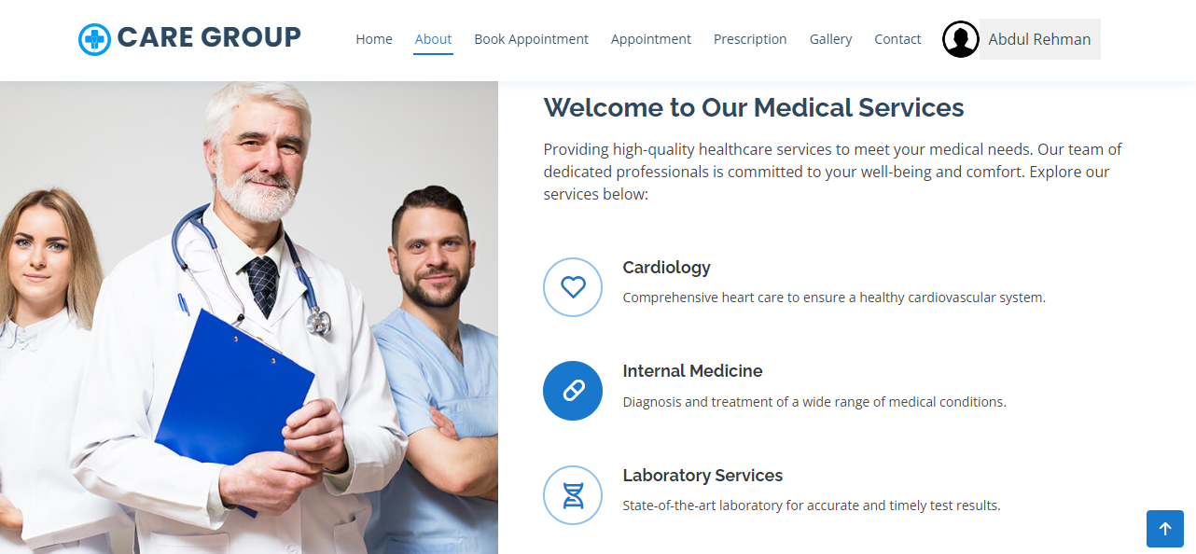

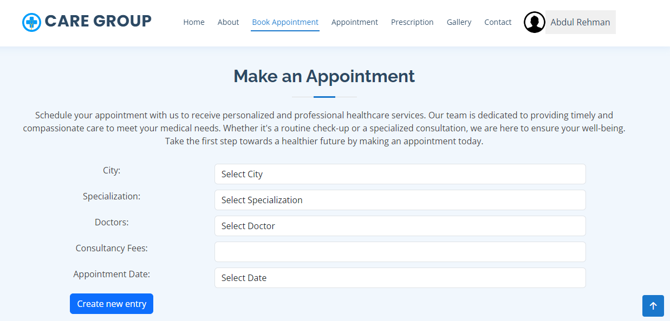

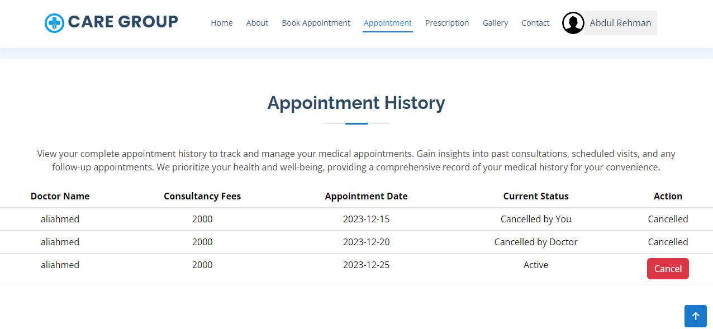

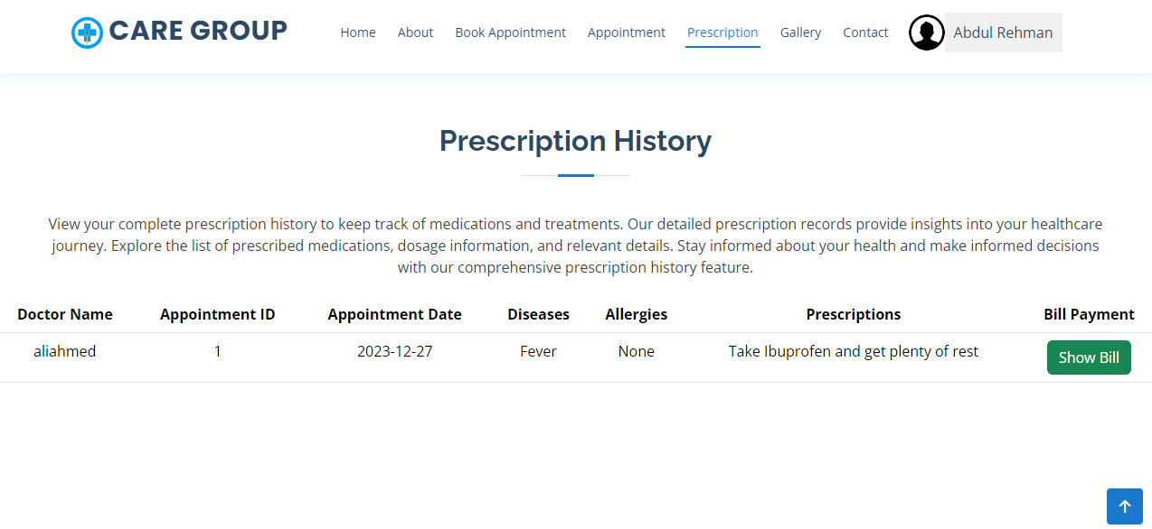



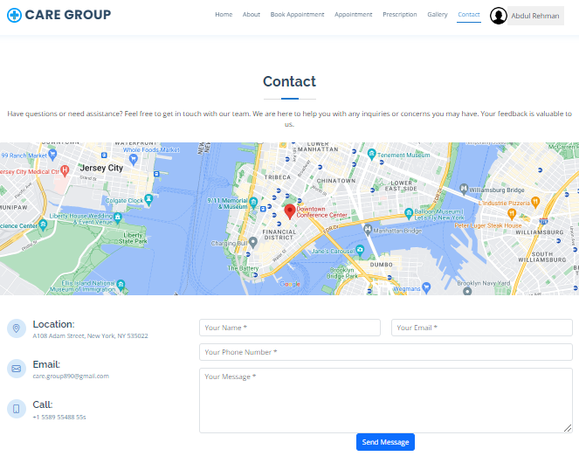

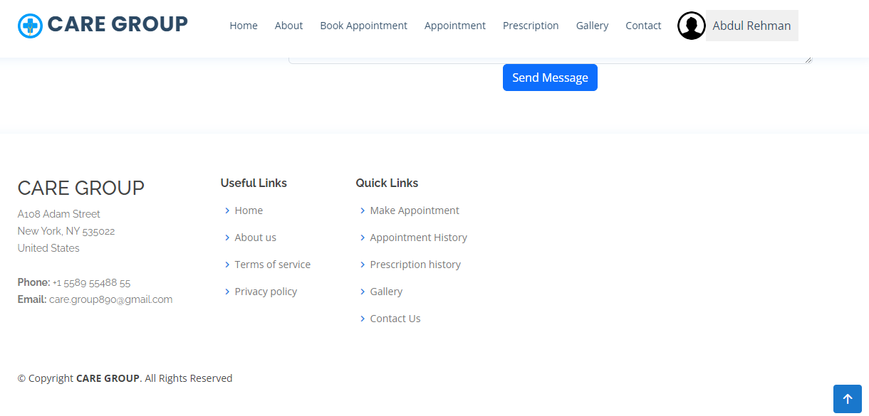

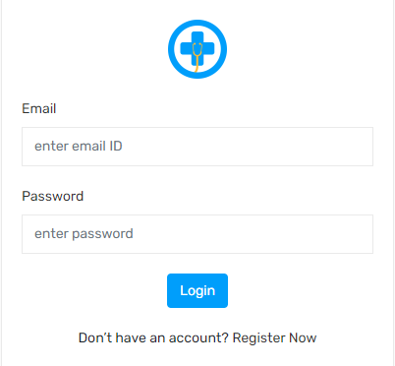

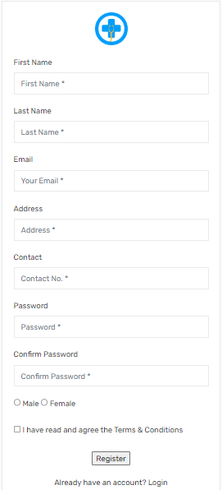

Admin Dashboard

Dashboard:

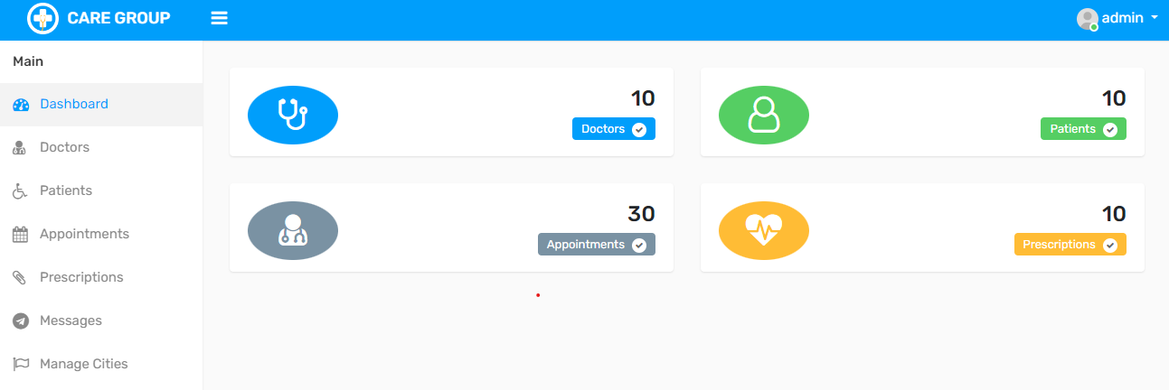

Doctors List:

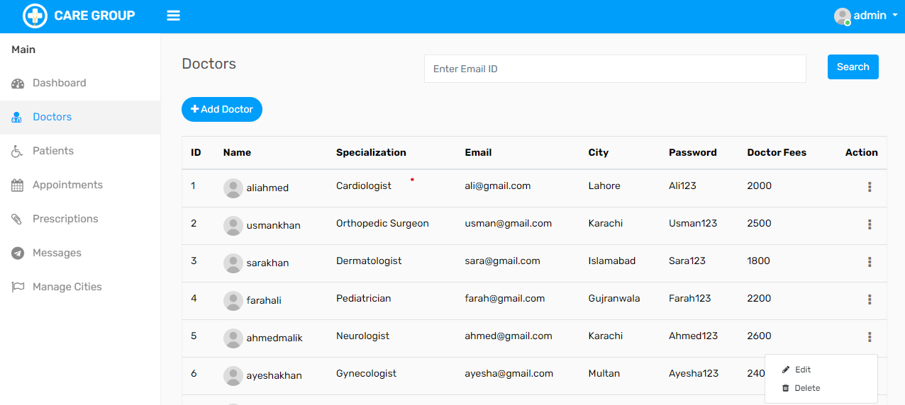

Add Doctors:

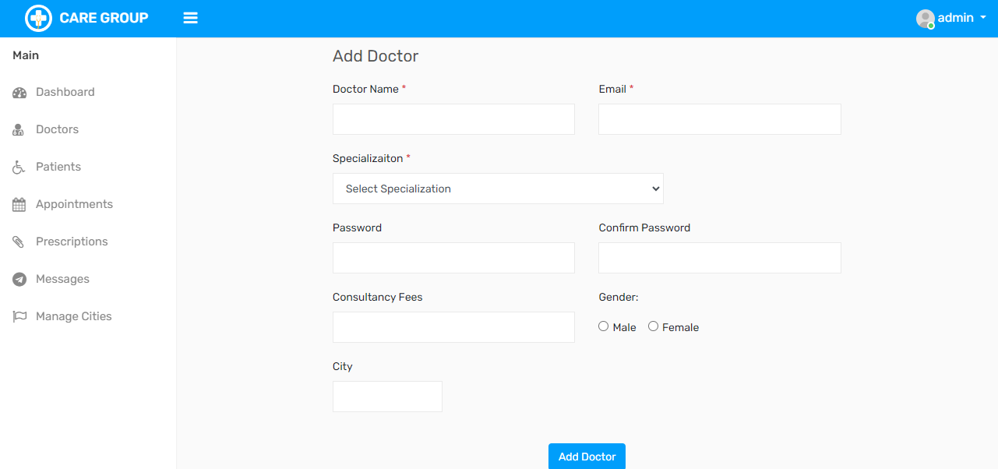

Patients List:

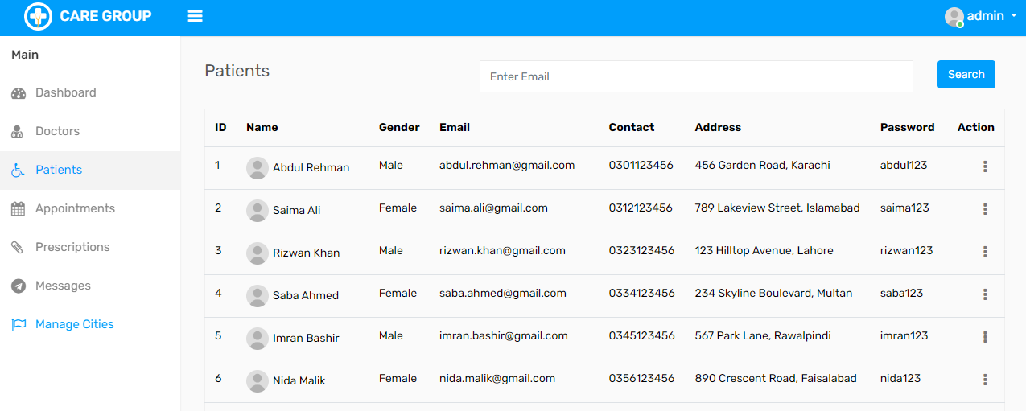

Appointments:

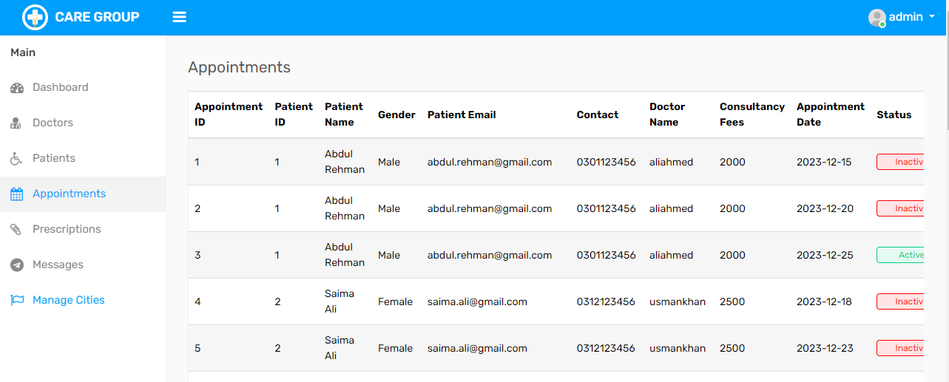

Prescriptions:

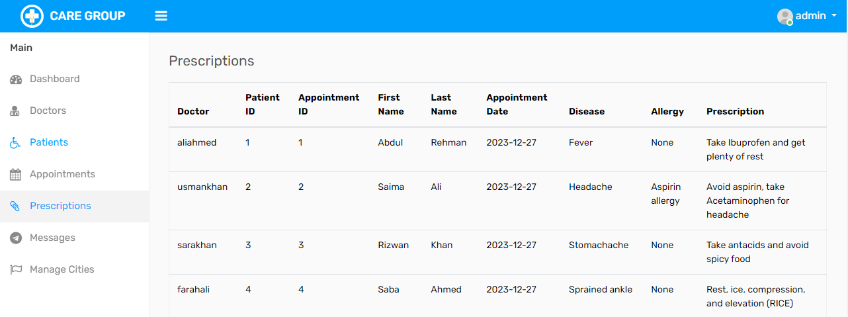

Messages:

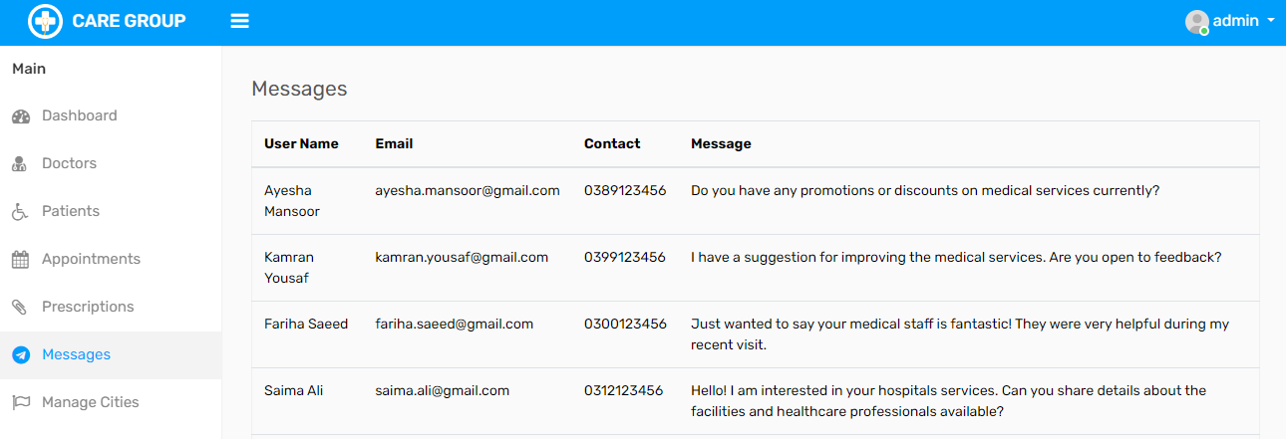

Cities management:

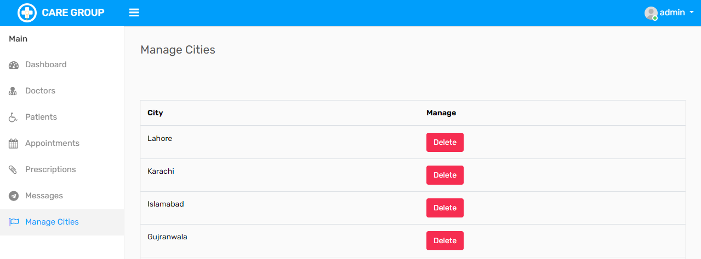

Doctor Dashboard

Dashboard:

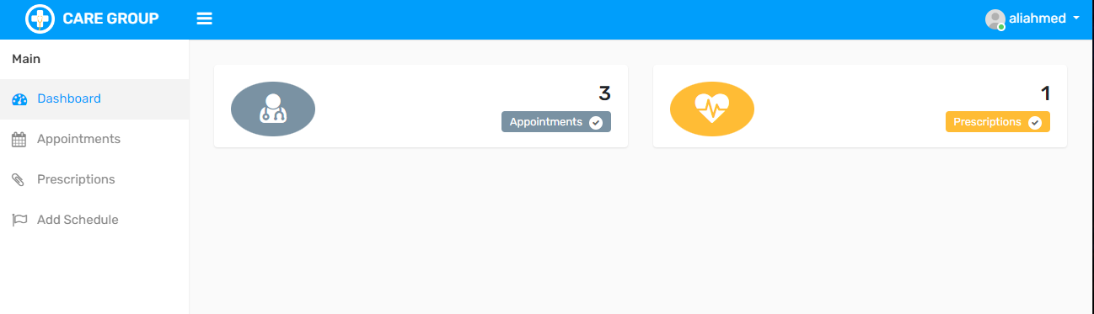

Appointments:

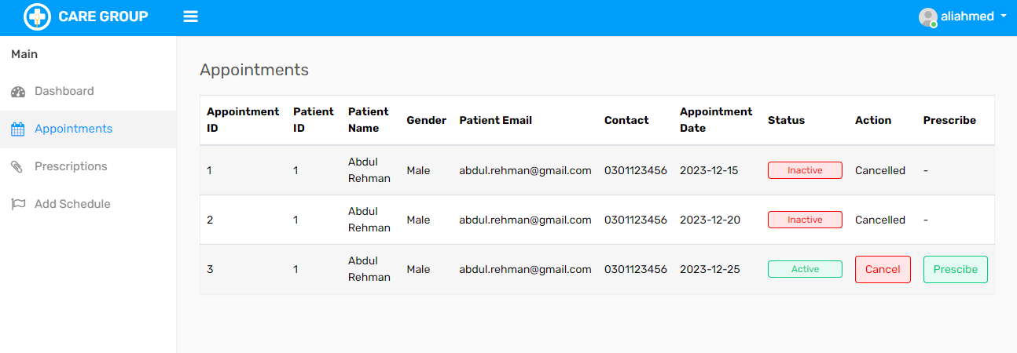

Prescribe:

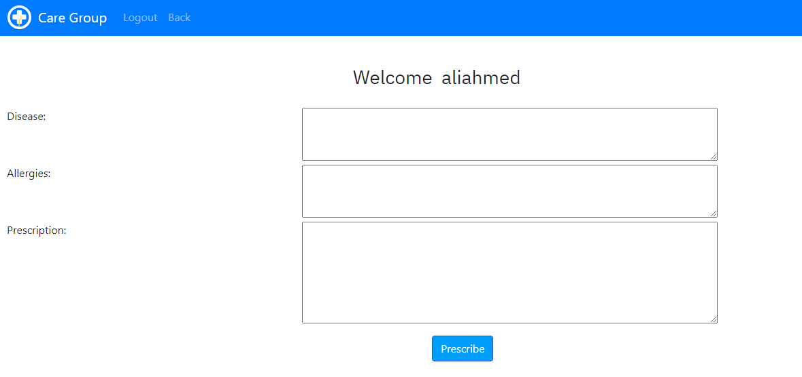

Prescriptions:

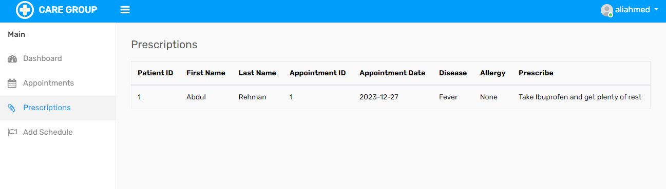

Add Schedule:

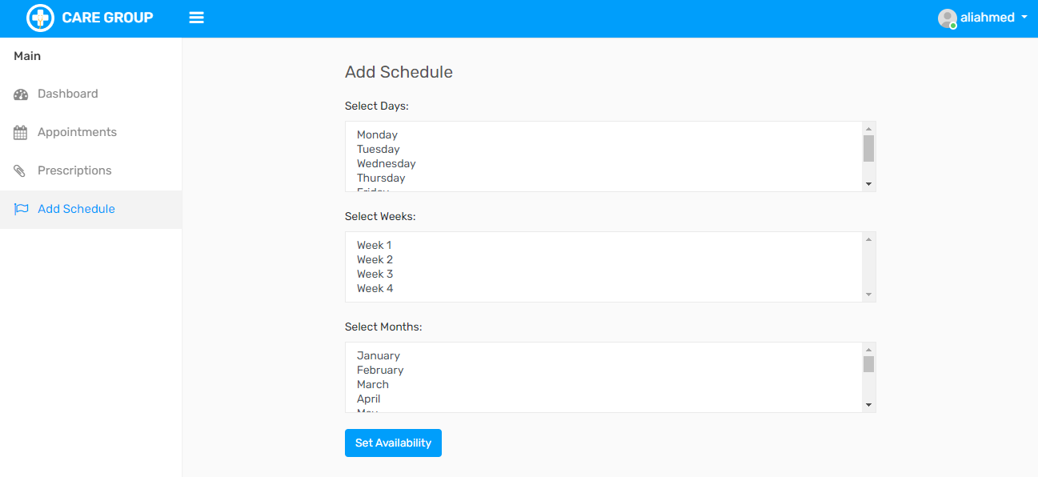

Login:

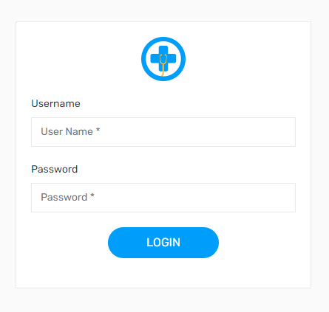

Developer Guide

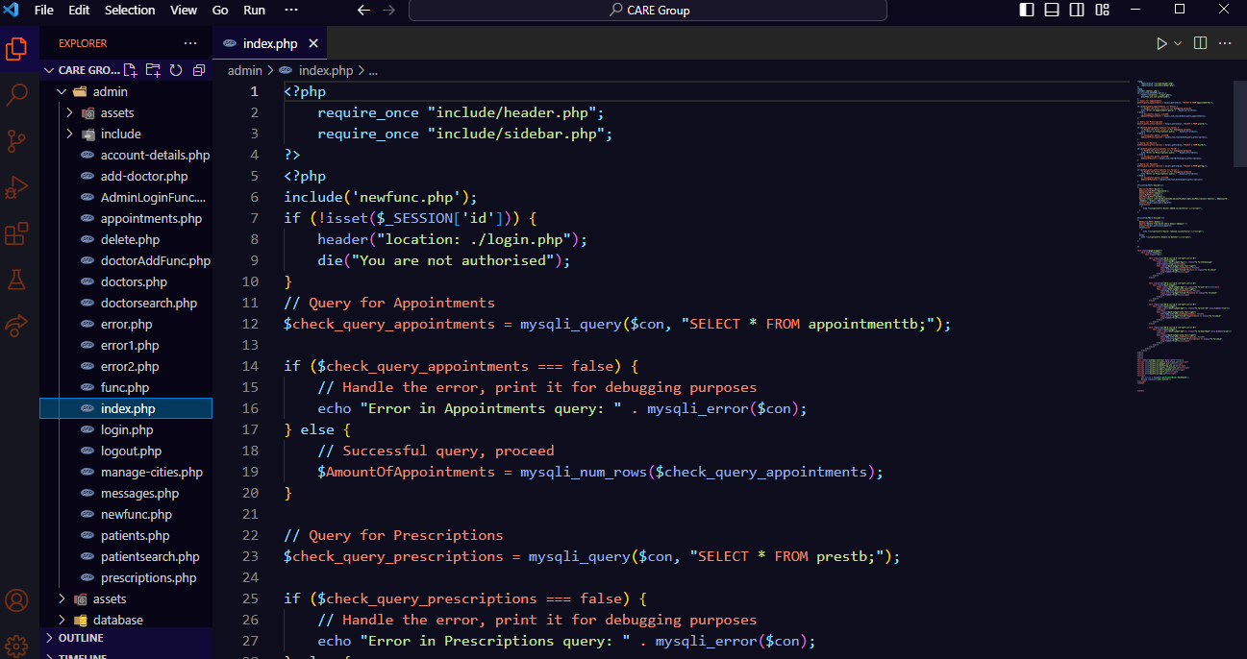

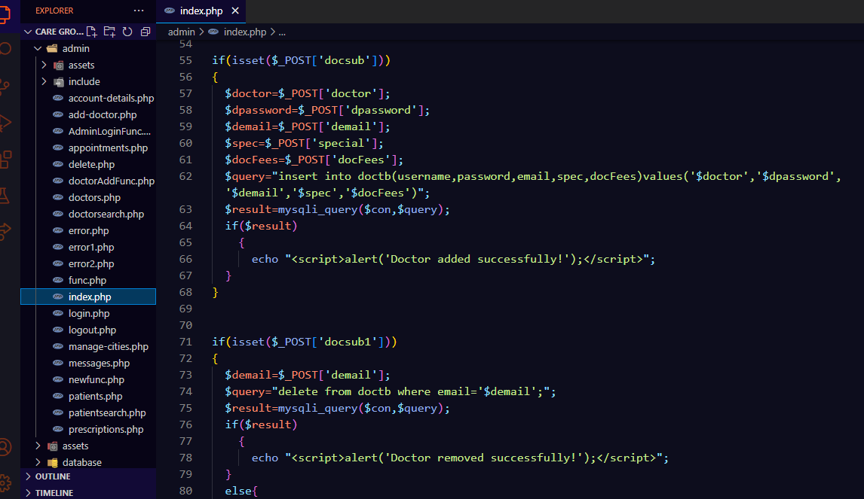
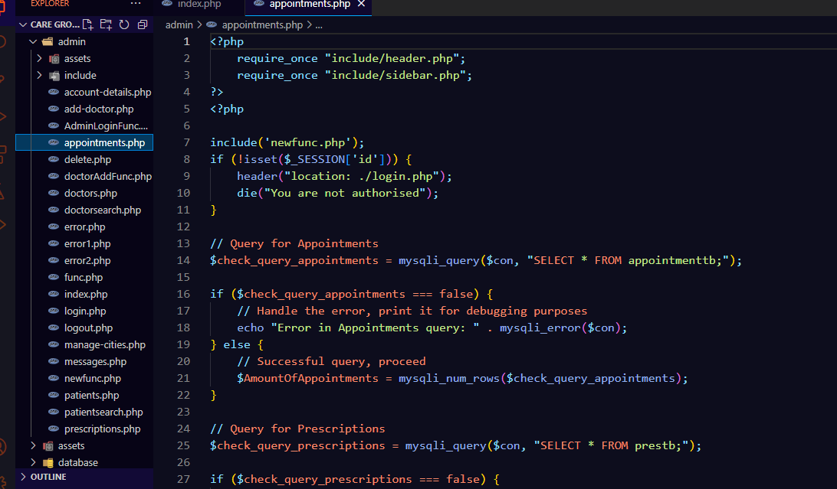

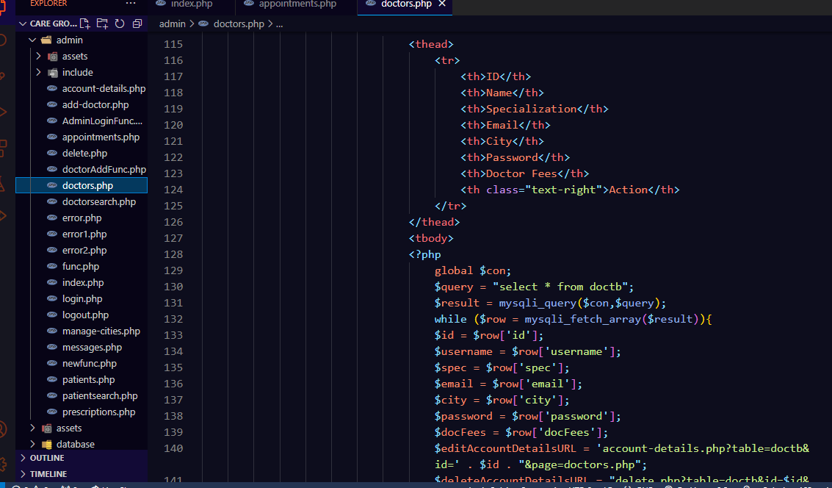

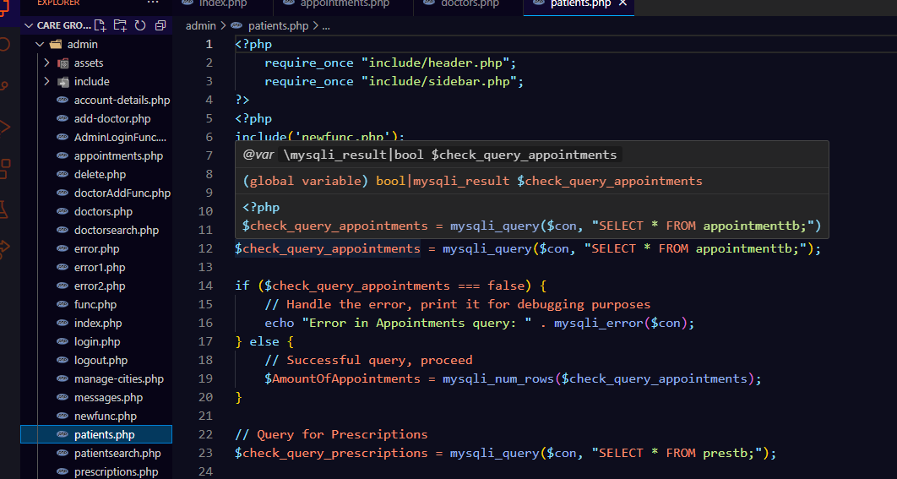

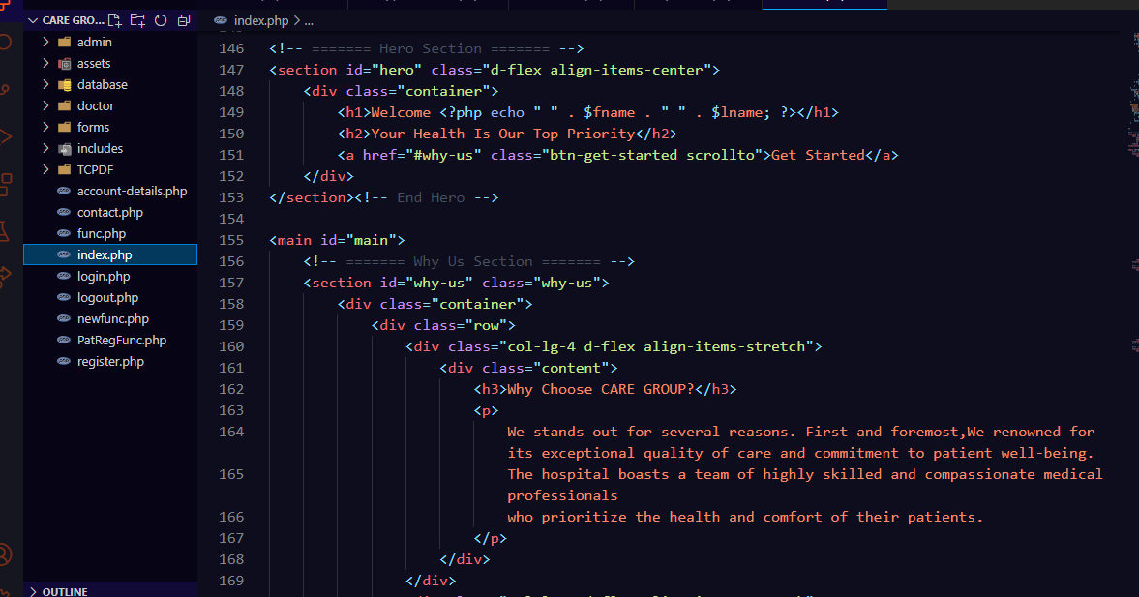

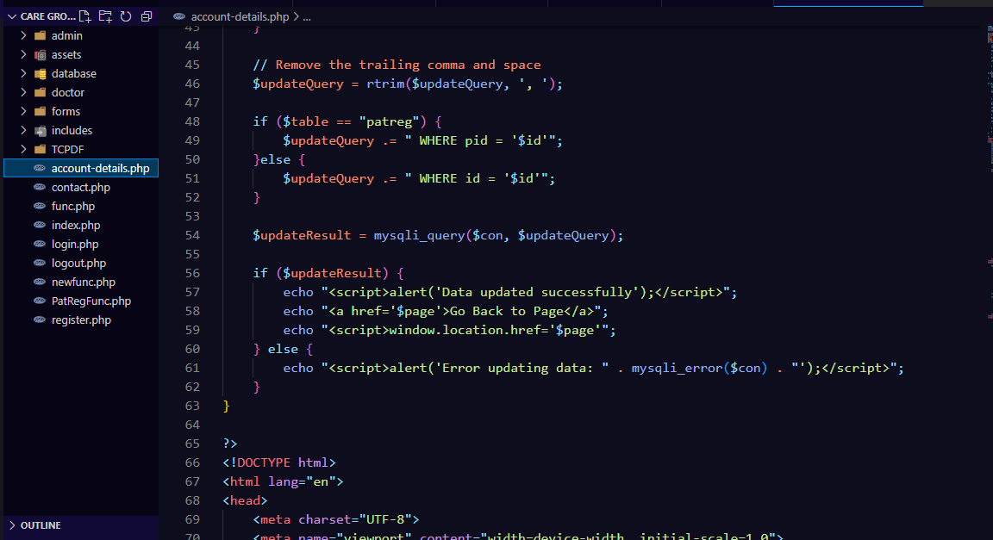

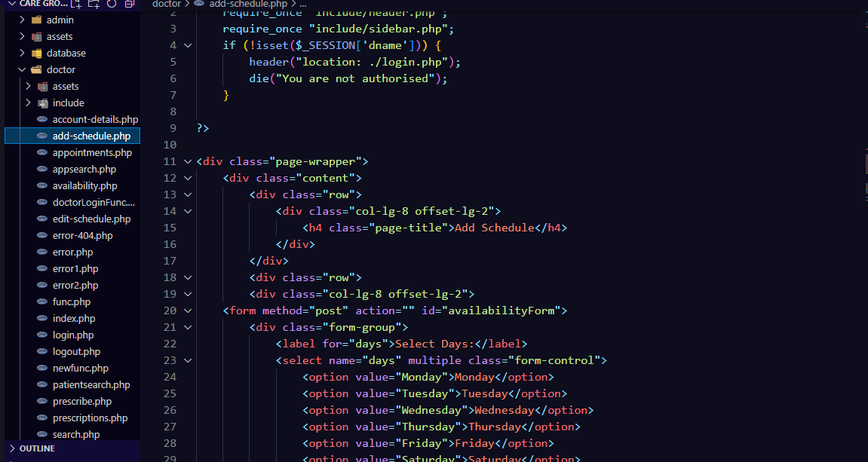

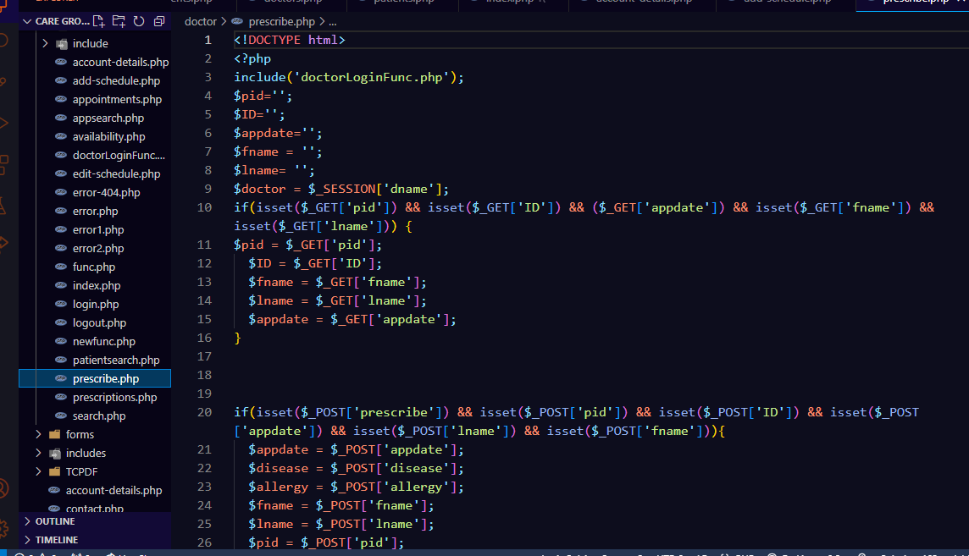

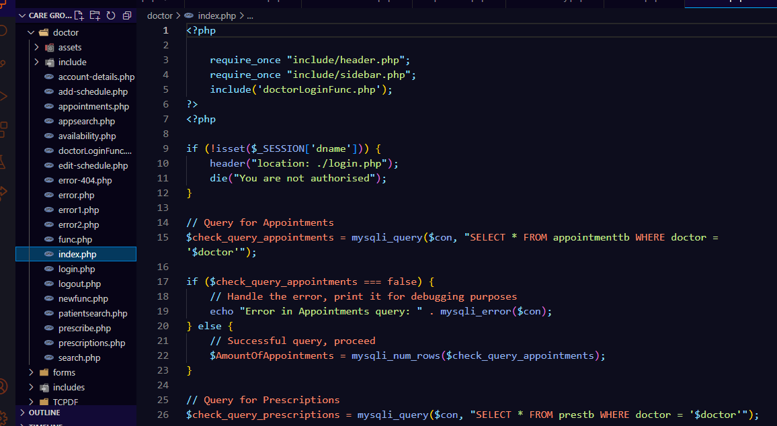

Task Sheet

Project Ref. No. |  | Project Title | Date of Preparation of Activity Plan
S.No | Task | CARE Group | Actual Days | Status
1 | Analysis | CARE Group | 2 | OK
2 | Design | CARE Group | 5 | OK
3 | Development | CARE Group | 10 | OK
4 | Testing | CARE Group | 8 | OK
5 | Documentation | CARE Group | 2 | OK

Checklist of Validation

Options | Validated
Do all numeric variables have a default value of zero? | YES
Does the administer have all the rights to create and delete record? | YES
Are all the record properly fed into the appropriate database? | YES
Have all the modules been properly integrated are completely functional? | YES
Have all the Design and coding Standards been followed and implemented? | YES
Is the GUI design consistent all over? | YES
Is the navigation sequence correct through all the forms/screens in the application? | YES
Is exception handling mechanism implemented in all the screens? | YES
Are all the program codes working? | YES

Submission of Checklist

S.NO | Particulars | YES | NO | NA | COMMENTS
1 | Are all users able to search for a particular record? | YES
2 | Are all old records properly saved and retrieved when required? | YES
3 | Have all modular been properly integrated and are completely functional? | YES
4 | Are GUI contents devoid of spelling mistake? | YES
5 | Is the application user-friendly? | YES
6 | Is the project published properly into the setup file? | YES

Flowcharts

Admin:

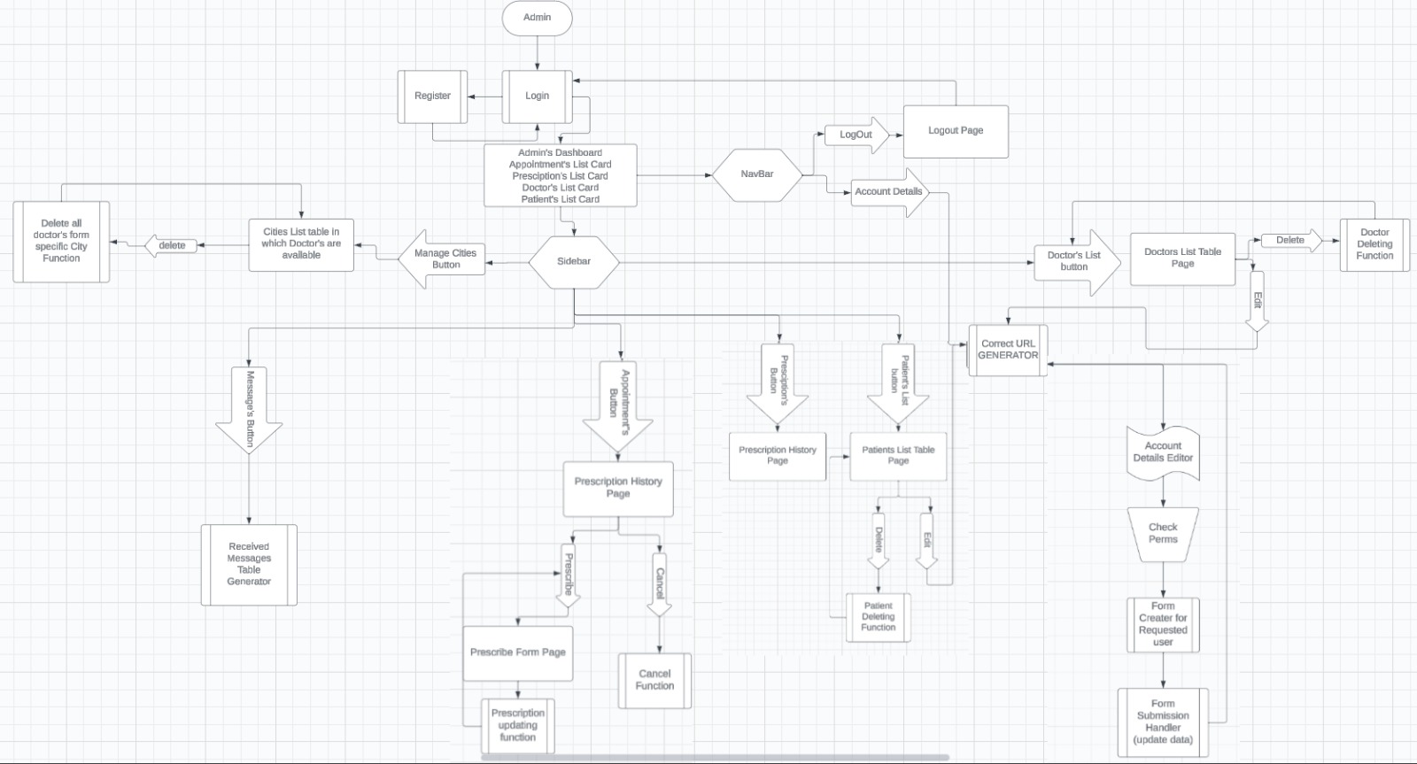

Doctor:

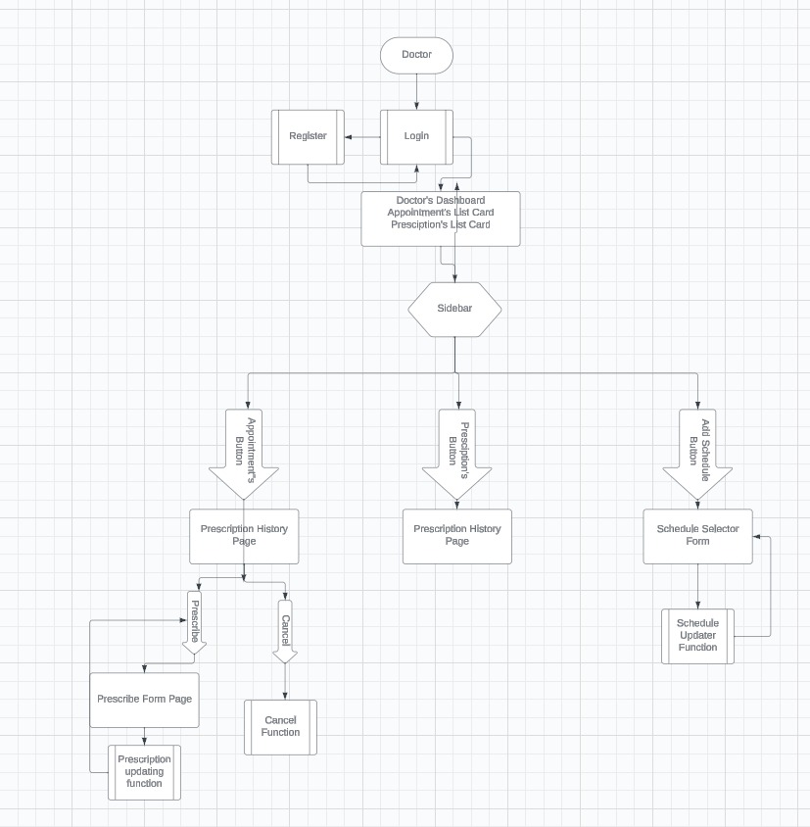

Patient:

